Technical Specification Documents
Project: SUNNDARI – Beauty Services Marketplace Platform
Document Version: 1.0
Prepared for: Development Team
Date: 13 April 2026

1. API Specification Document
This document defines the complete RESTful API specification (Version v1) for the SUNNDARI platform. All endpoints follow REST principles, use JSON as the data format, and enforce HTTPS. Authentication is JWT-based after OTP verification. Rate limiting (100 requests/minute per IP) and request validation are mandatory.
Base URL: https://api.sunndari.in/v1
Authentication:
- Header: Authorization: Bearer <JWT> (for protected routes)
- All mobile app endpoints require a valid JWT after OTP login.
- Admin dashboard uses role-based access control (RBAC) with additional X-Role: admin header.
Common Response Structure
JSON

{
"success": boolean,
"data": object | array | null,
"message": string,
"error_code": string | null
}

1.1 Authentication & Common Endpoints
Method | Endpoint | Description | Request Body / Query Params | Response (Success) | Protected
POST | /auth/otp/request | Request OTP for mobile login | { "phone": "+91xxxxxxxxxx" } | { "success": true, "message": "OTP sent" } | No
POST | /auth/otp/verify | Verify OTP and issue JWT | { "phone": "...", "otp": "123456" } | { "success": true, "data": { "token": "jwt...", "role": "customer" } } | No
GET | /profile | Fetch current user profile | — | User profile object | Yes
PUT | /profile | Update profile | Profile fields (role-specific) | Updated profile | Yes

1.2 Customer App Endpoints
Method | Endpoint | Description | Key Parameters / Body | Response | Protected
GET | /customer/search | Search artists | Query: ?location=...&category=...&budget_min=...&rating=... | Paginated artist list | Yes
GET | /customer/artists/{artist_id} | View artist profile | Path: artist_id | Full artist profile + portfolio + packages | Yes
GET | /customer/availability/{artist_id} | Check artist availability | Query: ?date=YYYY-MM-DD | Available slots | Yes
POST | /customer/bookings | Create booking | { "package_id": "...", "booking_date": "...", "location_type_id": "...", "address_id": "..." } | Booking object + payment intent | Yes
POST | /customer/payments/initiate | Initiate payment | { "booking_id": "...", "amount": ..., "method": "UPI" } | Payment gateway order details | Yes
POST | /customer/payments/webhook | Payment gateway webhook (internal) | Gateway payload | Update payment_status | No (signed)
GET | /customer/bookings | List customer bookings | Query: ?status=pending | Paginated bookings | Yes
POST | /customer/reviews | Submit review (post-service) | { "booking_id": "...", "rating": 5, "comment": "..." } | Review object | Yes

1.3 Artist App Endpoints
Method | Endpoint | Description | Key Parameters / Body | Response | Protected
POST | /artist/portfolios | Upload portfolio media | Multipart: file + { "service_category_id": "..." } | Portfolio object | Yes
GET | /artist/portfolios | List own portfolios | — | Array of portfolios | Yes
POST | /artist/packages | Create pricing package | { "package_name": "...", "base_price": 5000, ... } | Package object | Yes
GET | /artist/packages | List own packages | — | Array of packages | Yes
POST | /artist/availability | Set/block availability slots | Array of slots | Confirmation | Yes
GET | /artist/bookings | List incoming bookings | Query: ?status=pending | Paginated bookings | Yes
PUT | /artist/bookings/{booking_id}/accept | Accept booking | Path: booking_id | Updated booking | Yes
PUT | /artist/bookings/{booking_id}/reject | Reject booking | Path: booking_id + { "reason": "..." } | Updated booking | Yes
PUT | /artist/bookings/{booking_id}/status | Update booking status | Path: booking_id + { "status_id": "..." } | Updated booking | Yes
GET | /artist/earnings | Earnings dashboard | Query: ?from_date=...&to_date=... | Earnings summary + transactions | Yes

1.4 Admin Dashboard Endpoints (Web)
Method | Endpoint | Description | Key Parameters / Body | Response | Protected
GET | /admin/users | List users (customers/artists) | Query: ?role=artist&status=pending | Paginated users | Admin
PUT | /admin/artists/{artist_id}/approve | Approve/reject artist profile | Path: artist_id + { "status_id": "..." } | Updated profile | Admin
GET | /admin/bookings | Monitor all bookings | Query filters | Paginated bookings | Admin
PUT | /admin/bookings/{booking_id}/refund | Process refund | Path: booking_id + { "reason": "..." } | Updated transaction | Admin
GET | /admin/reports/revenue | Revenue & commission report | Query: ?from=...&to=... | CSV/PDF export ready data | Admin
POST | /admin/portfolios/{portfolio_id}/moderate | Moderate portfolio | Path: portfolio_id + { "status_id": "..." } | Updated portfolio | Admin

Error Handling: Standard HTTP status codes with consistent error responses. All endpoints include comprehensive input validation using JSON Schema.
API Documentation Tools: OpenAPI 3.0 specification will be generated and hosted on Swagger UI (/docs).

2. Entity-Relationship (ER) Diagram
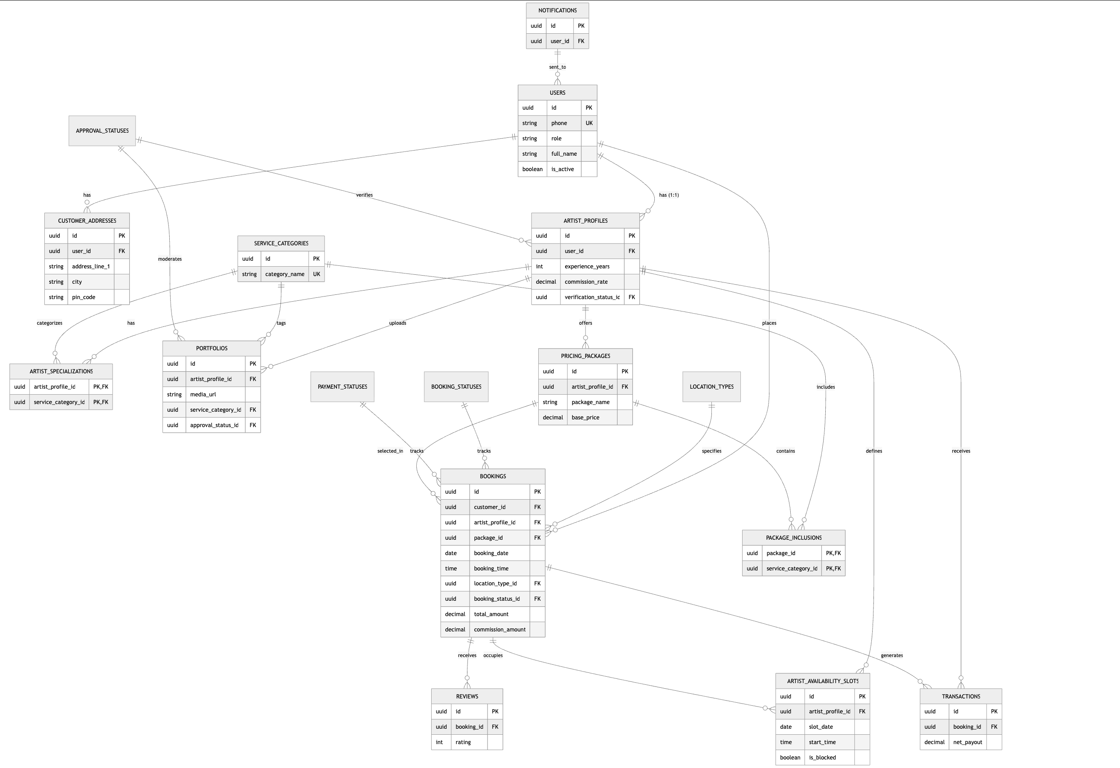

The following is a complete ER diagram represented in Mermaid syntax. Copy and paste into any Mermaid renderer (e.g., Mermaid Live Editor) for visual rendering.

Key Relationships Summary
- One-to-Many: Users → Addresses, Users → Bookings
- Many-to-Many: Artists ↔ Service Categories (via junctions)
- One-to-One: Users ↔ Artist Profiles (for role = artist)

3. Database Migration Scripts (PostgreSQL)
The following is a complete, ready-to-execute migration script set. Run in order. All tables include audit columns. Use UUID extension and PostGIS for geospatial support.
SQL

-- Migration 001: Extensions & Lookup Tables
CREATE EXTENSION IF NOT EXISTS "uuid-ossp";
CREATE EXTENSION IF NOT EXISTS "postgis";

-- Lookup Tables
CREATE TABLE service_categories (
id UUID PRIMARY KEY DEFAULT uuid_generate_v4(),
category_name VARCHAR(100) NOT NULL UNIQUE,
description TEXT,
is_active BOOLEAN DEFAULT true,
created_at TIMESTAMP DEFAULT CURRENT_TIMESTAMP,
updated_at TIMESTAMP DEFAULT CURRENT_TIMESTAMP
);

CREATE TABLE location_types (
id UUID PRIMARY KEY DEFAULT uuid_generate_v4(),
type_name VARCHAR(50) NOT NULL UNIQUE,
is_active BOOLEAN DEFAULT true,
created_at TIMESTAMP DEFAULT CURRENT_TIMESTAMP,
updated_at TIMESTAMP DEFAULT CURRENT_TIMESTAMP
);

CREATE TABLE booking_statuses (
id UUID PRIMARY KEY DEFAULT uuid_generate_v4(),
status_name VARCHAR(50) NOT NULL UNIQUE,
is_terminal BOOLEAN DEFAULT false,
created_at TIMESTAMP DEFAULT CURRENT_TIMESTAMP,
updated_at TIMESTAMP DEFAULT CURRENT_TIMESTAMP
);

CREATE TABLE payment_statuses (
id UUID PRIMARY KEY DEFAULT uuid_generate_v4(),
status_name VARCHAR(50) NOT NULL UNIQUE,
is_active BOOLEAN DEFAULT true,
created_at TIMESTAMP DEFAULT CURRENT_TIMESTAMP,
updated_at TIMESTAMP DEFAULT CURRENT_TIMESTAMP
);

CREATE TABLE approval_statuses (
id UUID PRIMARY KEY DEFAULT uuid_generate_v4(),
status_name VARCHAR(50) NOT NULL UNIQUE,
created_at TIMESTAMP DEFAULT CURRENT_TIMESTAMP,
updated_at TIMESTAMP DEFAULT CURRENT_TIMESTAMP
);

-- Core Tables
CREATE TABLE users (
id UUID PRIMARY KEY DEFAULT uuid_generate_v4(),
phone VARCHAR(20) UNIQUE NOT NULL,
role VARCHAR(20) NOT NULL CHECK (role IN ('customer', 'artist', 'admin')),
full_name VARCHAR(100) NOT NULL,
email VARCHAR(255) UNIQUE,
is_active BOOLEAN DEFAULT true,
created_at TIMESTAMP DEFAULT CURRENT_TIMESTAMP,
updated_at TIMESTAMP DEFAULT CURRENT_TIMESTAMP
);

CREATE TABLE customer_addresses (
id UUID PRIMARY KEY DEFAULT uuid_generate_v4(),
user_id UUID REFERENCES users(id) ON DELETE CASCADE,
address_line_1 VARCHAR(255) NOT NULL,
address_line_2 VARCHAR(255),
city VARCHAR(100) NOT NULL,
pin_code VARCHAR(6) NOT NULL,
is_default BOOLEAN DEFAULT false,
created_at TIMESTAMP DEFAULT CURRENT_TIMESTAMP,
updated_at TIMESTAMP DEFAULT CURRENT_TIMESTAMP
);

CREATE TABLE artist_profiles (
id UUID PRIMARY KEY DEFAULT uuid_generate_v4(),
user_id UUID UNIQUE REFERENCES users(id) ON DELETE CASCADE,
experience_years INTEGER CHECK (experience_years >= 0),
service_city VARCHAR(100) NOT NULL,
service_radius_km INTEGER CHECK (service_radius_km BETWEEN 1 AND 100),
bio TEXT,
verification_status_id UUID REFERENCES approval_statuses(id),
commission_rate DECIMAL(5,2) CHECK (commission_rate BETWEEN 10 AND 25),
created_at TIMESTAMP DEFAULT CURRENT_TIMESTAMP,
updated_at TIMESTAMP DEFAULT CURRENT_TIMESTAMP
);

-- Junction & Supporting Tables
CREATE TABLE artist_specializations (
artist_profile_id UUID REFERENCES artist_profiles(id) ON DELETE CASCADE,
service_category_id UUID REFERENCES service_categories(id),
PRIMARY KEY (artist_profile_id, service_category_id)
);

CREATE TABLE portfolios (
id UUID PRIMARY KEY DEFAULT uuid_generate_v4(),
artist_profile_id UUID REFERENCES artist_profiles(id) ON DELETE CASCADE,
media_url TEXT NOT NULL,
media_type VARCHAR(10) NOT NULL CHECK (media_type IN ('image', 'video')),
service_category_id UUID REFERENCES service_categories(id),
caption TEXT,
approval_status_id UUID REFERENCES approval_statuses(id),
created_at TIMESTAMP DEFAULT CURRENT_TIMESTAMP,
updated_at TIMESTAMP DEFAULT CURRENT_TIMESTAMP
);

CREATE TABLE pricing_packages (
id UUID PRIMARY KEY DEFAULT uuid_generate_v4(),
artist_profile_id UUID REFERENCES artist_profiles(id) ON DELETE CASCADE,
package_name VARCHAR(100) NOT NULL,
base_price DECIMAL(10,2) NOT NULL CHECK (base_price >= 500),
duration_minutes INTEGER NOT NULL,
created_at TIMESTAMP DEFAULT CURRENT_TIMESTAMP,
updated_at TIMESTAMP DEFAULT CURRENT_TIMESTAMP
);

CREATE TABLE package_inclusions (
package_id UUID REFERENCES pricing_packages(id) ON DELETE CASCADE,
service_category_id UUID REFERENCES service_categories(id),
PRIMARY KEY (package_id, service_category_id)
);

CREATE TABLE artist_availability_slots (
id UUID PRIMARY KEY DEFAULT uuid_generate_v4(),
artist_profile_id UUID REFERENCES artist_profiles(id) ON DELETE CASCADE,
slot_date DATE NOT NULL,
start_time TIME NOT NULL,
end_time TIME NOT NULL,
is_blocked BOOLEAN DEFAULT false,
booking_id UUID REFERENCES bookings(id) ON DELETE SET NULL,
created_at TIMESTAMP DEFAULT CURRENT_TIMESTAMP,
updated_at TIMESTAMP DEFAULT CURRENT_TIMESTAMP
);

CREATE TABLE bookings (
id UUID PRIMARY KEY DEFAULT uuid_generate_v4(),
customer_id UUID REFERENCES users(id),
artist_profile_id UUID REFERENCES artist_profiles(id),
package_id UUID REFERENCES pricing_packages(id),
booking_date DATE NOT NULL,
booking_time TIME NOT NULL,
location_type_id UUID REFERENCES location_types(id),
address_id UUID REFERENCES customer_addresses(id),
booking_status_id UUID REFERENCES booking_statuses(id),
total_amount DECIMAL(10,2) NOT NULL,
commission_amount DECIMAL(10,2) NOT NULL,
payment_status_id UUID REFERENCES payment_statuses(id),
special_instructions TEXT,
created_at TIMESTAMP DEFAULT CURRENT_TIMESTAMP,
updated_at TIMESTAMP DEFAULT CURRENT_TIMESTAMP
);

CREATE TABLE reviews (
id UUID PRIMARY KEY DEFAULT uuid_generate_v4(),
booking_id UUID REFERENCES bookings(id) ON DELETE CASCADE,
customer_id UUID REFERENCES users(id),
artist_profile_id UUID REFERENCES artist_profiles(id),
rating INTEGER CHECK (rating BETWEEN 1 AND 5) NOT NULL,
comment TEXT,
created_at TIMESTAMP DEFAULT CURRENT_TIMESTAMP
);

CREATE TABLE transactions (
id UUID PRIMARY KEY DEFAULT uuid_generate_v4(),
booking_id UUID REFERENCES bookings(id),
artist_profile_id UUID REFERENCES artist_profiles(id),
amount DECIMAL(10,2) NOT NULL,
commission_amount DECIMAL(10,2) NOT NULL,
net_payout DECIMAL(10,2) NOT NULL,
transaction_type VARCHAR(20) NOT NULL,
status UUID REFERENCES payment_statuses(id),
payout_reference VARCHAR(255),
created_at TIMESTAMP DEFAULT CURRENT_TIMESTAMP
);

CREATE TABLE notifications (
id UUID PRIMARY KEY DEFAULT uuid_generate_v4(),
user_id UUID REFERENCES users(id) ON DELETE CASCADE,
title VARCHAR(255),
message TEXT,
type VARCHAR(50),
is_read BOOLEAN DEFAULT false,
created_at TIMESTAMP DEFAULT CURRENT_TIMESTAMP
);

CREATE TABLE audit_logs (
id UUID PRIMARY KEY DEFAULT uuid_generate_v4(),
user_id UUID REFERENCES users(id),
action VARCHAR(100) NOT NULL,
entity_type VARCHAR(50) NOT NULL,
entity_id UUID NOT NULL,
details JSONB,
created_at TIMESTAMP DEFAULT CURRENT_TIMESTAMP
);

-- Indexes for performance
CREATE INDEX idx_bookings_customer ON bookings(customer_id);
CREATE INDEX idx_bookings_artist ON bookings(artist_profile_id);
CREATE INDEX idx_portfolios_artist ON portfolios(artist_profile_id);
CREATE INDEX idx_availability_artist_date ON artist_availability_slots(artist_profile_id, slot

